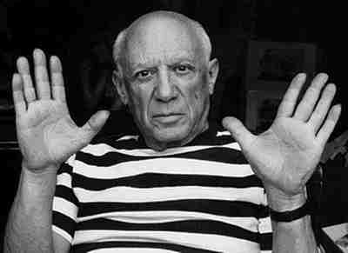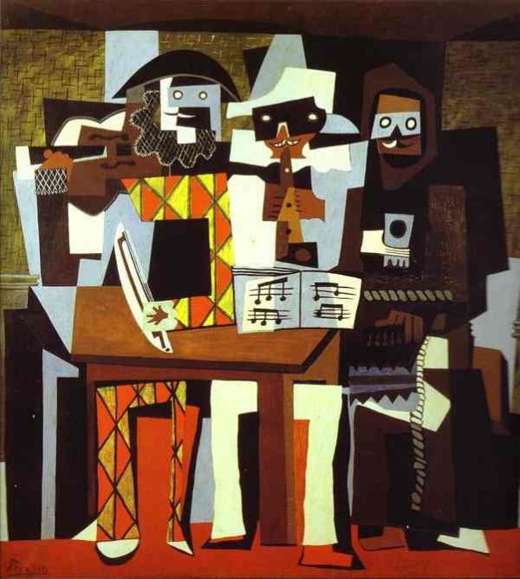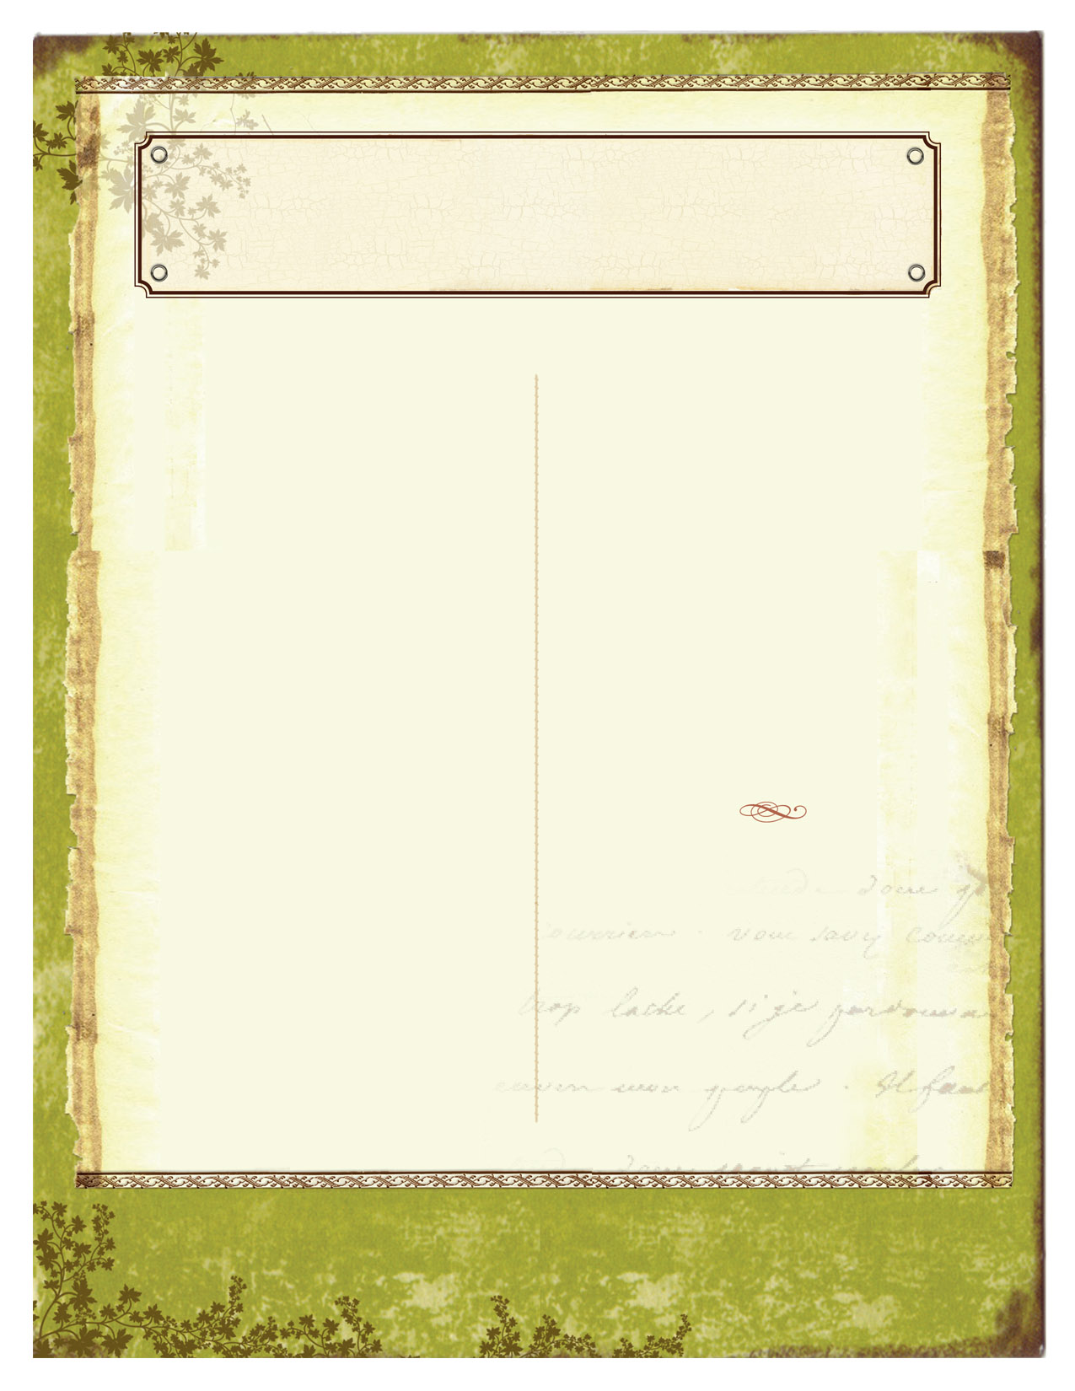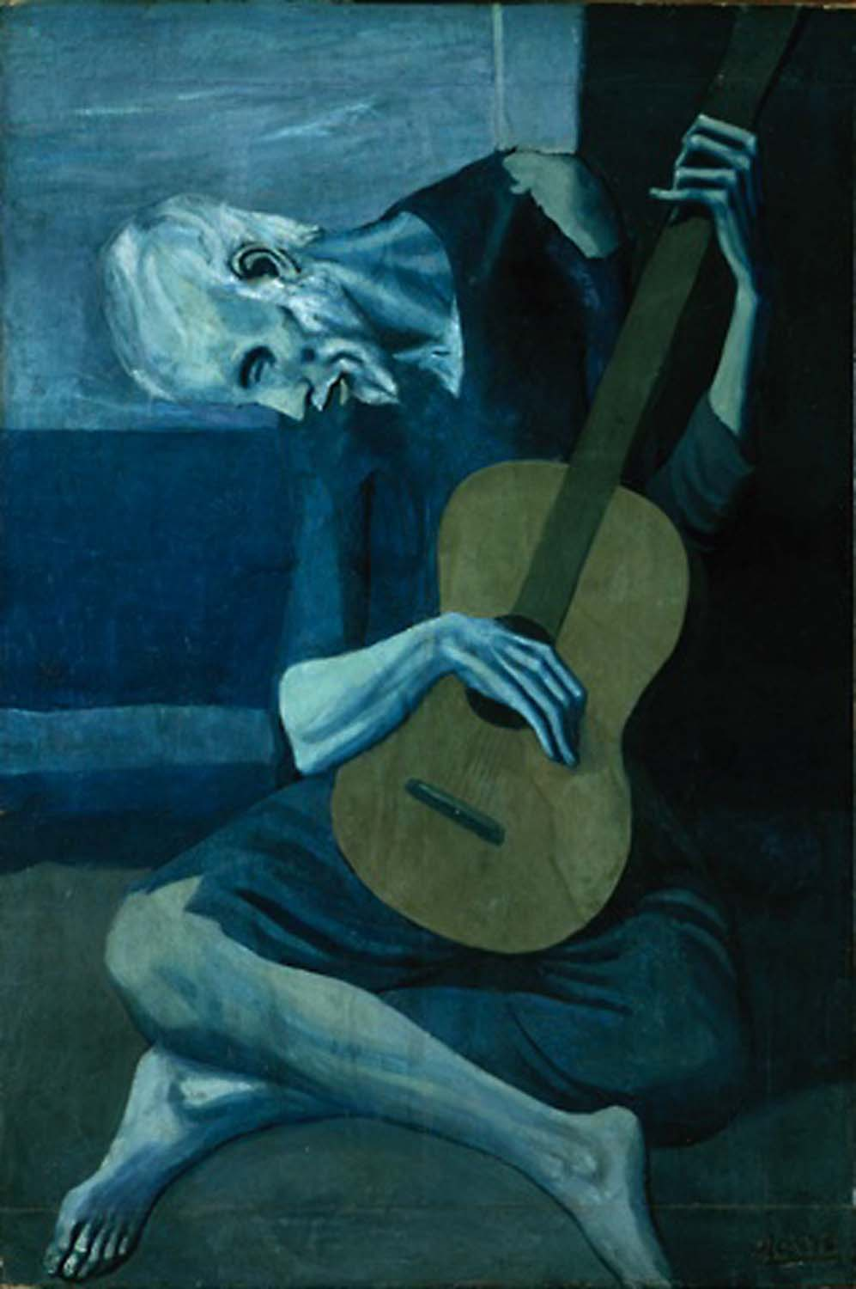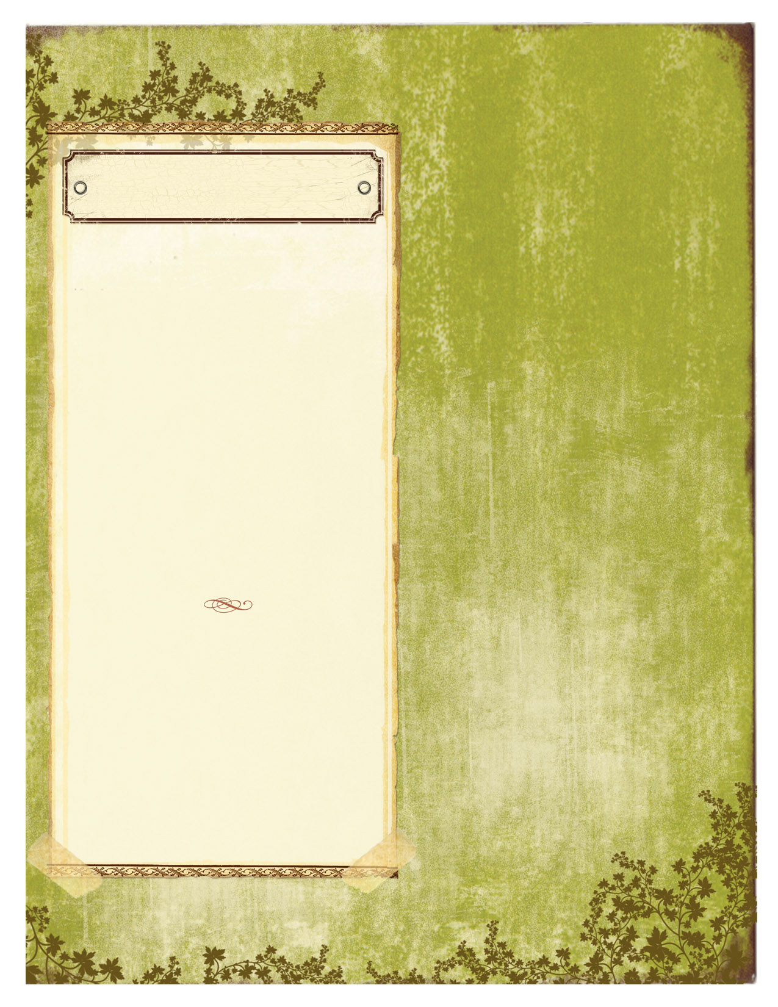

Pablo Picasso and below his painting *Three Musicians*, 1921

The Master Monday artist for the month of October is Picasso. An interesting fact about Picasso is that he was very successful in his later life as an artist but in the early years while living in Paris he could not afford furniture so he painted his furniture onto his apartment wall.

5th Graders have been working hard on their Color Wheel Symbol project. They learned about Primary, Secondary, and Tertiary/Intermediate colors. They learned how to mix paint and that sometimes it isn’t always easy to get the color they want. They created a symbol about them that they used to paint and create a color wheel.

4th Graders are finishing their Radial Symmetry project. They used a color scheme of their choice (primary, secondary, warm & cool, and complementary colors). They used origami base folds and created a radially balanced design using those folds. The students love this project and I have found that all students are able to feel successful.

3rd Graders had to set aside their Adinkra cloth printmaking project to make artwork for their musical. They learned about making tints and shades and how to make a monochromatic color scheme. Each student created a picture that represented their interests inside their mosaic piece. The theme of the project was the eighth habit. The eight habit talks about finding your voice and inspiring others to do the same. So the project was how you can express yourselves individually and come together with others.

OCTOBER 2017

The Bulldog Art Room News

CREATIVITY. IMAGINATION. FUN.

VOL. #4 ISSUE #2

The Old Guitarist, Pablo Picasso1903-04

“Art is not what you see, but what you make others see.” **Edgar Degas**

2nd Graders learned about an artist named Gustav Klimt. They are creating a tree of life inspired by his artwork. We talked about the many shapes and lines that can be found in his artwork. We will be finishing up the project using patterns and designs.

1st Graders are in the middle of a project based on the book, “*Monsters Don’t Eat Broccoli*.” They learned about cityscapes and created one on their paper. We are currently making textured paper for our monster skins.

Kindergarteners made some color wheel birds sitting on a wire. They learned about Primary colors and that you can’t mix colors to make them. They also learned what colors you get when you mix Primary colors together.

.

### Have you been to the Saint Louis Art Museum lately? Admission and parking are free and they have over 33,000 pieces of art! (They have several Picasso works too).

### Currently they have an exhibit called: *A Century of Japanese Prints* You can view this exhibit until January 2018.

Projects & News

Continue newsletter text here. Continue newsletter text here. Continue newsletter text here. Continue newsletter text here. Continue newsletter text here. Continue newsletter text here. Continue newsletter text here. Continue newsletter text here. Continue newsletter text here. Continue newsletter text here. Continue newsletter text here. Continue newsletter text here. Continue newsletter text here. Continue newsletter text here. Continue newsletter text here. Continue newsletter text here. Continue newsletter text here. Continue newsletter text here Continue newsletter text here

Continue newsletter text here. Continue newsletter text here. Continue newsletter text here. Continue newsletter text here. Continue newsletter text here. Continue newsletter text here. Continue newsletter text here. Continue newsletter text here. Continue newsletter text here.

Continue newsletter text here. Continue newsletter text here. Continue newsletter text here. Continue newsletter text here. Continue newsletter text here. Continue newsletter text here. Continue newsletter text here. Continue newsletter text here. Continue newsletter text here. Continue newsletter text here. Continue newsletter text here. Continue newsletter text here.

Continue newsletter text here. Continue newsletter text here. Continue newsletter text here. Continue newsletter text here. Continue newsletter text here. Continue newsletter text here.

Continue newsletter text here. Continue newsletter text here. Continue newsletter text here. Continue newsletter text here. Continue newsletter text here. Continue newsletter text here. Continue newsletter text here. Continue newsletter text here.

Continue newsletter text here. Continue newsletter text here. Continue newsletter text here. Continue newsletter text here. Continue newsletter text here. Continue newsletter text here. Continue newsletter text here. Continue newsletter text here. Continue newsletter text here.